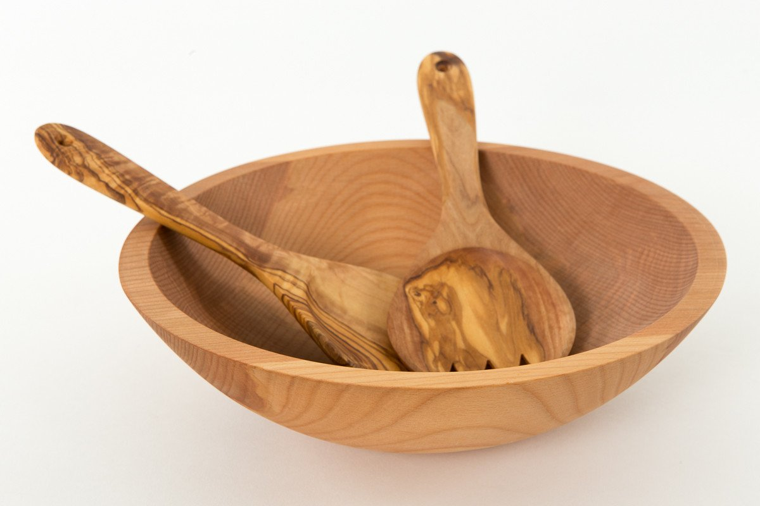
The Meal Service Program
Proof of Concept

Program Outline

Overview

The Meal Service is meant to be an intercultural and/or interreligious experience for a small group, based around the idea of the shared experience of eating. This program is all about the journey, rather than the final product, though the final product should reinforce the entire experience. The small group will spend quite a bit of time together, discussing topics of cultural identity and ethnic identity, cooking and teaching one another a dish that best represents who each person is, and finally, creating an worship experience where all of the liturgy is food.

Step 1: Forming the Group

Extend an invitation to the community (in this case, Decatur Presbyterian Church) for people to participate in an intercultural small group experience. Provide some details: You will be cooking, but cooking skill is not required. You will be talking about your own identity and cultural influence. You will be planning a prayer/worship service. Be vague enough to evoke curiosity, but provide enough detail to pique interest. Once enough people have expressed interest (6-8), begin the process of setting a date, time, and location for the first meeting. Everyone needs to be there, and there is no rush to completing the program, so find a day, time, and location that works for everyone.

Step 2: The First Meeting

During the first meeting, there are several objectives the group should complete. The first is to briefly get to know one another. Begin with introductions (names, identity markers of the person's choosing, why they were interested in the program, what they hope to get out of the program, etc.). After introductory discussion, share with the group the tentative plan for the program: Each person will decide on a dish or recipe they believe best represents who they are. Every meeting, at least one person will teach the group how to cook that dish, and lead discussion based on how they respond to the following questions: How does this dish represent you? What is the cultural origin of this dish? How did you come to know about this dish? What does this dish or ingredients reveal about the culture(s) from which it originated? The meeting should end with discussion about the day, time, and location of the next meeting, as well as who is cooking/teaching.

Step 3: Subsequent Meetings

The group will need to meet enough times so that every group member has the opportunity to cook/teach the dish that best represents them. This may take a considerable amount of time, but don't rush it. Ideally, it would be great if the group could meet weekly or bi-weekly, and have one person cook/teach per meeting. For a group of 6-8, this means this portion of the program would take 2-4 months. As stated above, every meeting, at least one person will teach the group how to cook that dish, and lead discussion based on how they respond to the following questions: How does this dish represent you? What is the cultural origin of this dish? How did you come to know about this dish? What does this dish or ingredients reveal about the culture(s) from which it originated?

Step 4: The Penultimate Meeting

Once each person has cooked/taught their own dish, the group will come together to plan a worship experience. The guiding principle of this worship experience is that the food is the only documented liturgy. The group will have to decide on which dish or dishes will represent each part of the worship experience. This means thinking theologically about not only what parts of the service the group thinks should be included (Call to Worship, Prayer of Confession, Prayer of Adoration, Reading of the Word and response, Affirmation of Faith, Benediction, etc.), but also what each dish claims or symbolizes about God. This process is meant to be creative and flexible. As a group, having learned and tasted each dish, decide on the order of the worship experiences and an explanation as to each decision the group makes.

Creating the Menu/Bulletin

Once dishes have been assigned to particular parts of the service, each member will be required to write a brief description of the dish, a brief explanation of its cultural and personal origin for the person it represents, and a brief explanation of why the group decided to put it at this point in the service. It would be acceptable to say what images or concepts the group hopes are evoked be each part of the service. Once each person has completed this, compile each part of the service into a single word document, which will serve as the bulletin for the worship experience.

Step 5: The Final Meeting/The Worship Experience

The group will come together a final time to actually have the worship experience. Members will bring their dishes already prepared. Each dish will be served according to the order of service decided on by the group in the last meeting. Once the meal service is over, the group will take some time to collect their thoughts and debrief on the overall experience. The group should engage with the following questions: What have I learned that I will take with me? What part of this experience did I find to be most challenging? How will this experience inform how I engage with intercultural or interreligious experiences moving forward? What is the next step in the dialogue about intercultural and/or interreligious topics?
After the Program has concluded

At the last meeting, the group can decide whether or not they want to make their menu/bulletin available to the wider community. If the group decides they are willing to share their menu/bulletin with wider community, they should compile all of the recipes for the dishes they made, in addition to the actual menu/bulletin, for distribution either online or physical copies in the community space.

If this program continues to occur, it might be fun to have an archive of all the different meal services that each group produces.

Final Notes

This program is meant to be flexible and adaptable. It can be focused on intercultural or interreligious dialogue, or both. Though the sample Menu/Bulletin provided is formatted like a Presbyterian worship service, the service itself can take whatever form the group decides. For an interreligious experience, the Menu/Bulletin can be modeled off an interfaith prayer service (with a pairing of prayers and dishes).

This program is meant to be scalable, though not directly. Since the cooking and teaching are such a large part of the program, it is not possible for the groups to be any size. Groups larger than 10 would be difficult logistically and programmatically. I would suggest larger groups be broken down into smaller groups. Another option would be for the small group to serve as leadership for the worship service at the end of the program that would be open to the wider community.

It is my hope that this program will not just be fun and engaging, but also confronting for the issues of injustice and privilege that are manifested, even in what we eat. I hope this program leads to deep theological, cultural, and interreligious dialogue about who each one of us is and how we can learn and grow from and with one another. For a community like Decatur, I would also use this program to highlight food issues in our community and globally, when it comes to access and waste.

